**Assignment 10.1**

**Problem​ ​Statement**

Given a sequence of n values x1, x2, ..., xn and a window size k>0, the k-th moving average of the given sequence is defined as follows:

The moving average sequence has n-k+1 elements as shown below.

The moving averages with k=4 of a ten-value sequence (n=10) is shown below

i 1 2 3 4 5 6 7 8 9 10

**===== == == == == == == == == == ==**

**Input 10 20 30 40 50 60 70 80 90 100**

**y1 25 = (10+20+30+40)/4**

**y2 35 = (20+30+40+50)/4**

**y3 45 = (30+40+50+60)/4**

**y4 55 = (40+50+60+70)/4**

**y5 65 = (50+60+70+80)/4**

**y6 75 = (60+70+80+90)/4**

**y7 85 = (70+80+90+100)/4**

**Thus, the moving average sequence has n-k+1=10-4+1=7 values.**

**Answer:**

**Create a moving avg function:**

def moving_average(tempList, nSize):

ret = np.cumsum(tempList, dtype=float)

ret[nSize:] = ret[nSize:] - ret[:-nSize]

return ret[nSize-1:]/nSize

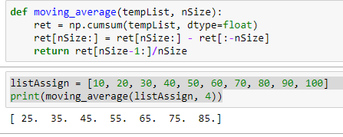

**Problem​ ​Statement 2 :**

**Write a function to find moving average in an array over a window:**

**Test it over [3, 5, 7, 2, 8, 10, 11, 65, 72, 81, 99, 100, 150] and window of 3.**

**Answer**

